VENUTAI CHAVAN COLLEGE, KARAD
SANSKRIT DEPARTMENT (2023-24)
Best Practices
- Display of Wallpaper
Sanskrit Din Celebration: Display of Wall Paper (31/08/2023)

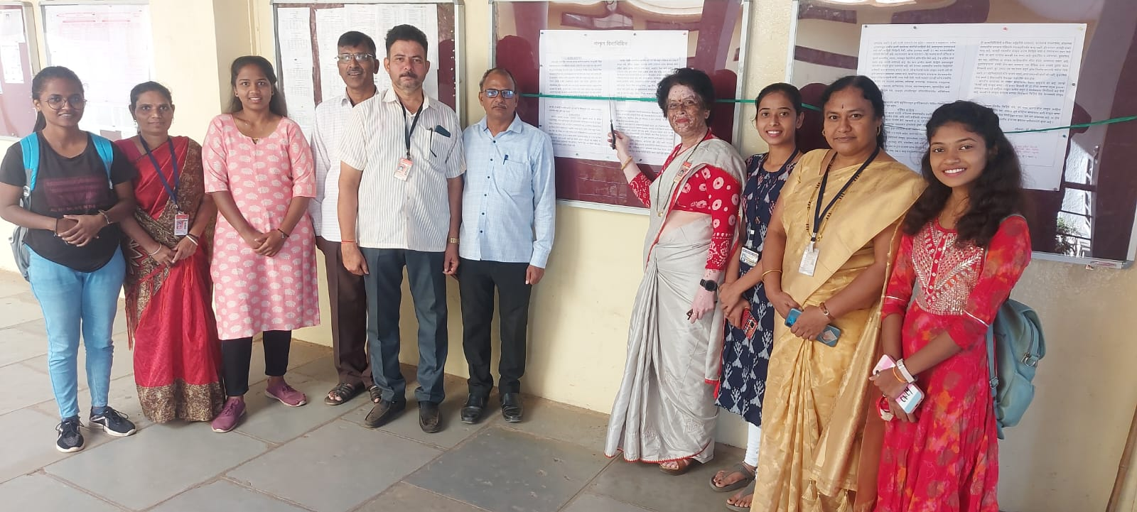
- Geeta Jayanti Celebration: Display of Wall Paper (22/12/2023)
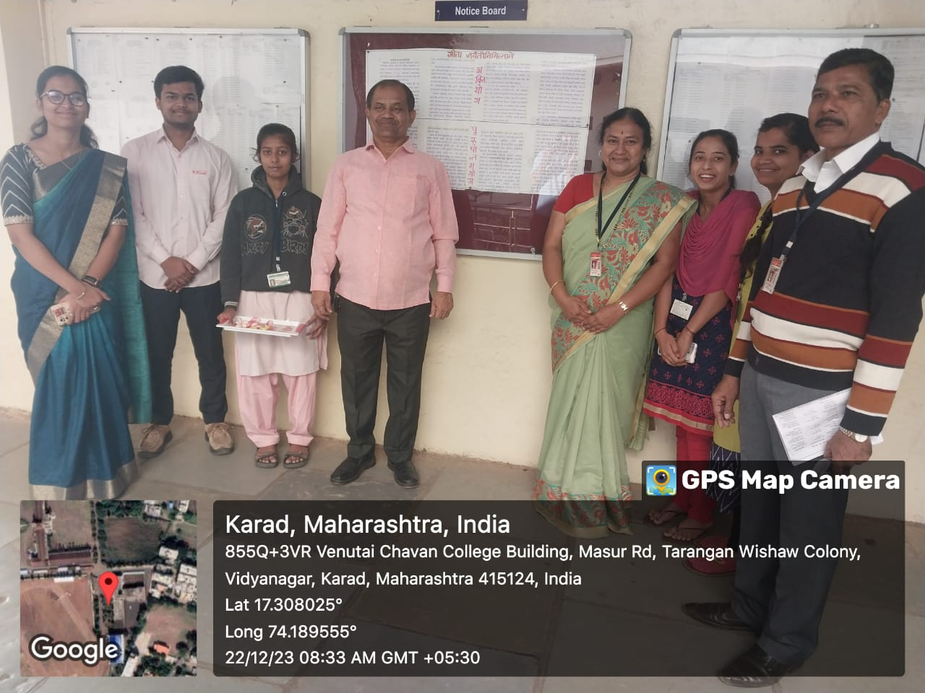

- Introduction of book by Students
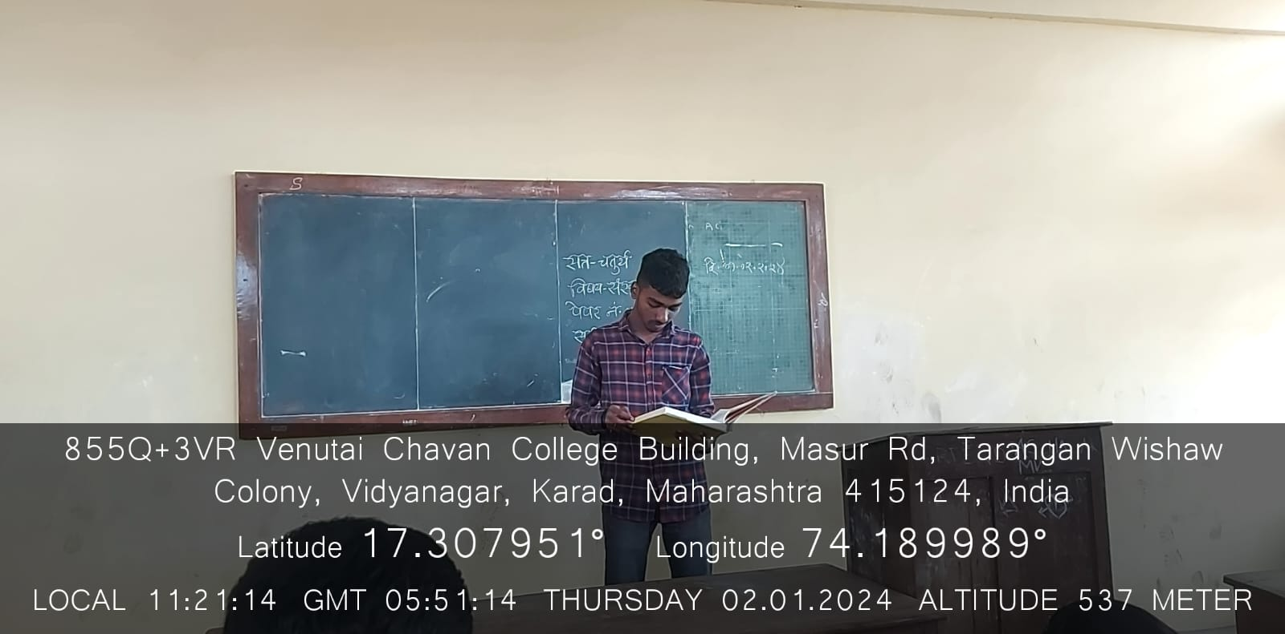
- Celebration of Special Days – Vachan-Prerana Din (16/10/2023)

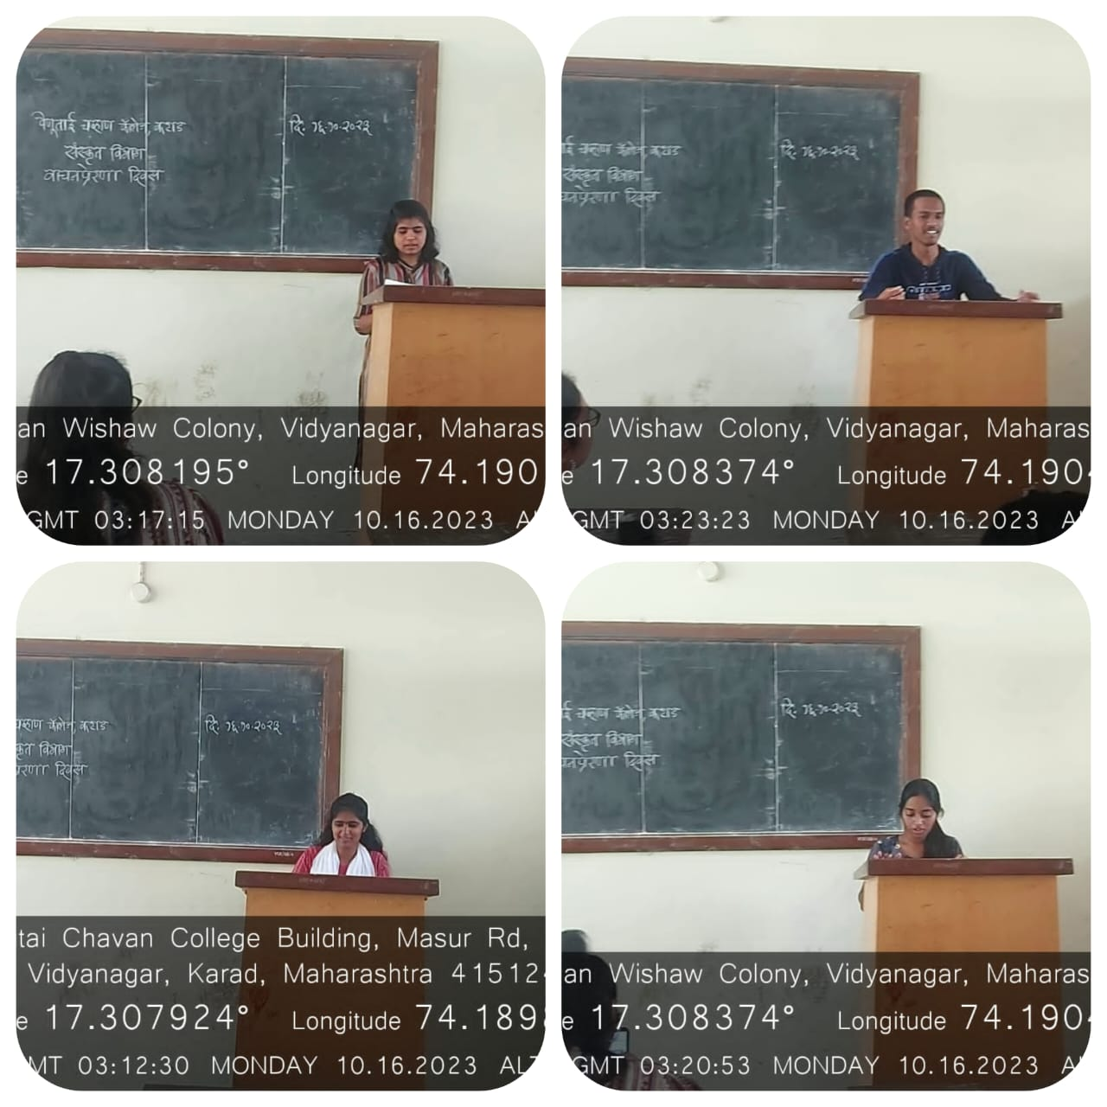
Pan. Jawaharlal Nehru Jayanti (14/11/2023) Donation of Study Material
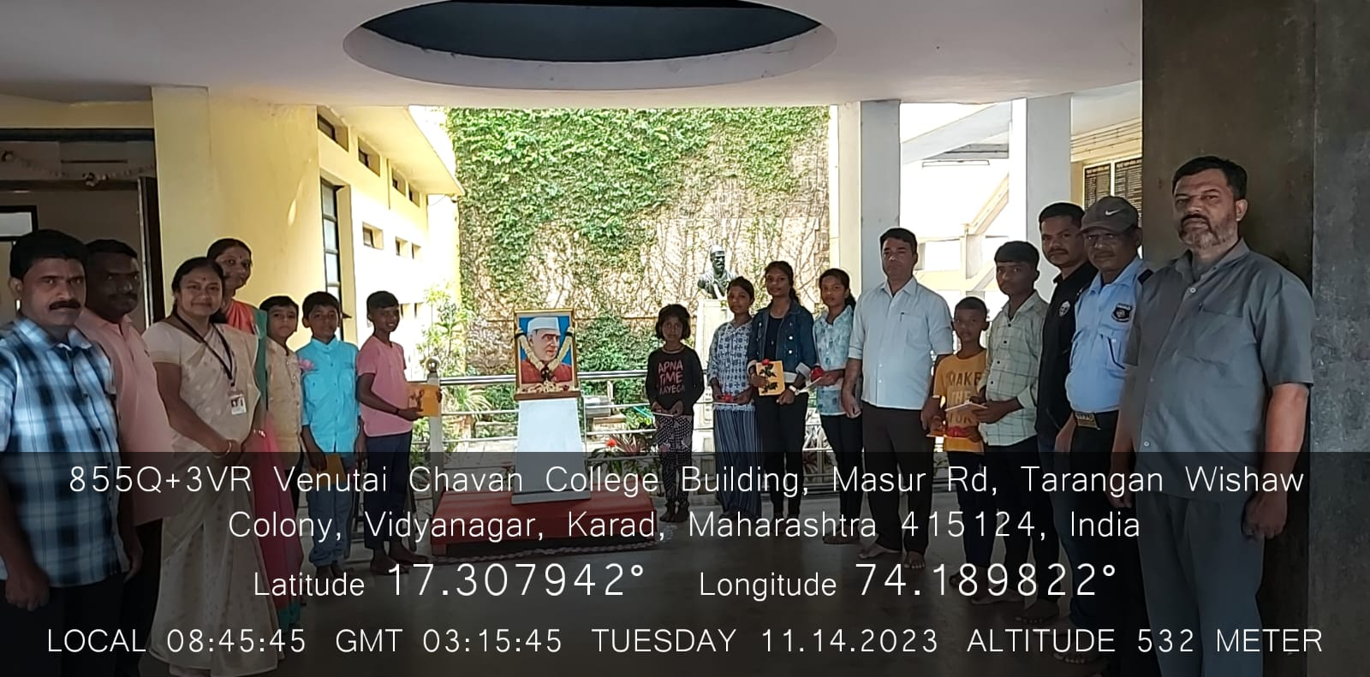

- Lecture by Alumni
